User Manual
How to share a file back



With This Manual You Will Learn
With This Manual You Will Learn 2
How to Securely Share a File with SpecterX 3
Outlook 3
Google Drive 3
Sharing files Securely from SpecterX Web Platform 3
Logging in to the SpecterX web platform 4
Sharing a file back 4
Sharing a File Securely From the Recipient Page 6
Sharing a file back 6

How to Securely Share a File with SpecterX
As a data collaboration platform, we encourage our users to share files back and forth, in order to reach their business goals. Therefore, sharing files back with the sender is one of the most prominent actions. SpecterX enables recipients to reply to the sender by sharing a file back in an intuitive, seamless flow.

The “Share a file back” flow depends on whether the recipient is a SpecterX user, or an external user who doesn’t have a SpecterX account. The latter will be able to use the “recipient page” or the SpecterX web platform. Members of the platform can either use the “recipient page” or the SpecterX web platform.

Sharing files back Securely from SpecterX Web Platform

Logging into the SpecterX web platform
Log into your tenant address https://XXX.specterx.com .

Sign in with your preferred authentication method.
If your organization has Microsoft or other identities, it is recommended to login via those services.
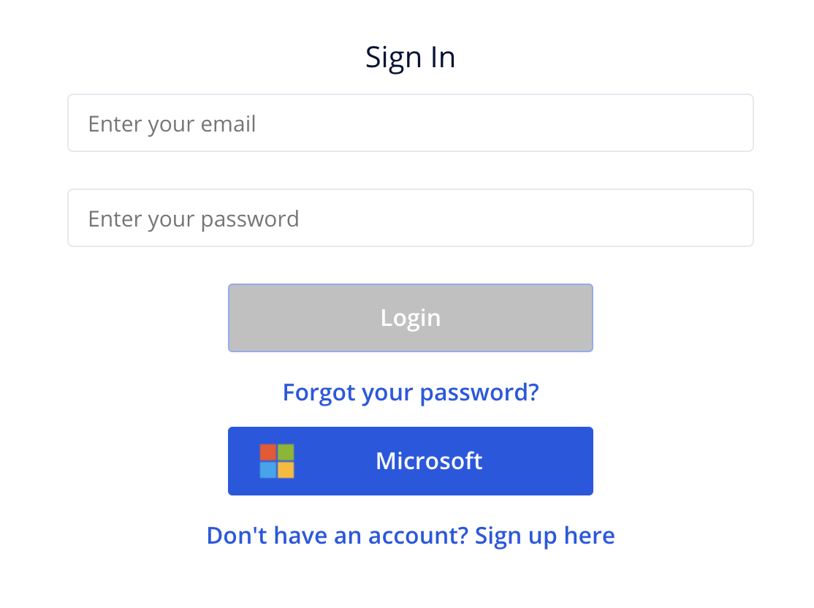

Sharing a file back
Click the ‘Share Files’ button, placed at the left hand side of the screen
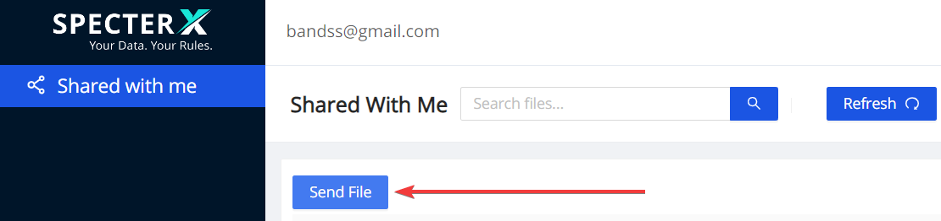

Drag your file to the gray box or click on the box and select the files you would like to share

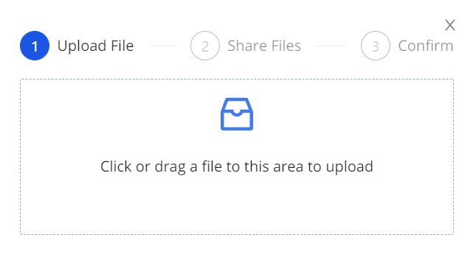
After choosing the files you would like to share, you’ll see an uploading progress bar. The file is now being uploaded to a secure location. This process will be complete once the progress bar turns green and reaches 100%.

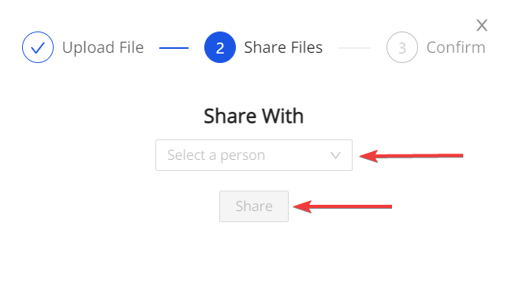
Choose the recipient email address under the ‘Select a person’ section and click Share to share the file with them.

Sharing a File Securely From the Recipient Page

Sharing a file back
In the SpecterX recipient page, click on the ‘Share a file back’ button

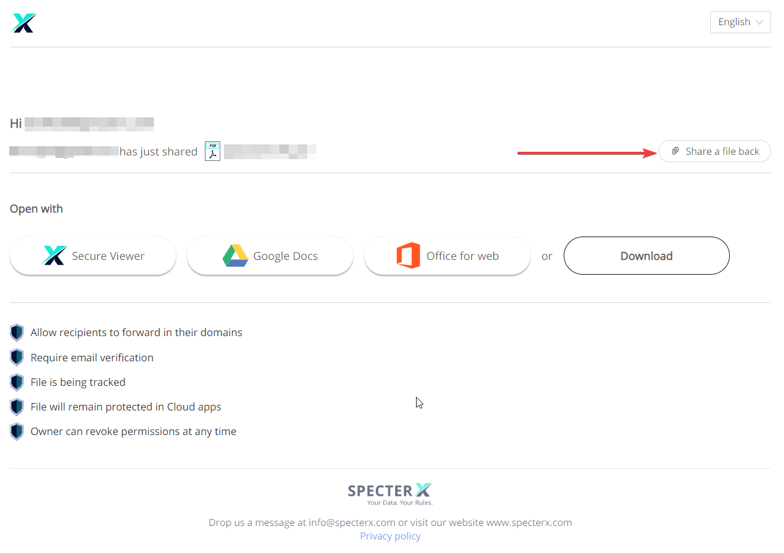

Drag your file to the gray box or click on the box and select the files you would like to share


After choosing the files you would like to share, you’ll see an uploading progress bar. The file is now being uploaded to a secure location. This process will be complete once the progress bar turns green and reaches 100%.


Choose the recipient email address under the ‘Select a person’ section and Share to share the file with them.

